Plamo Exhibition
American science Fiction Model Exhibition/Science Fiction
model National Competition

Prizes, Sponsors And Details of The Award Process

Version 1, January 2024

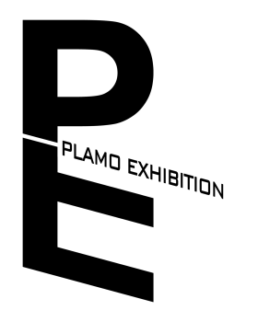

Plamo Exhibition Organizing Committee

Article 1 Organizing Committee Award Process Regulations
The Organizing Committee has the obligation to ensure that participants have the most fair and impartial selection criteria possible.

- According to the detailed schedule of each Plamo National Competition, the award ceremony needs to be arranged at the end of the schedule.

- The top three places, special prizes and the top three groups need to be publicly announced and awarded trophies, medals and prizes by the Plamo Organizing Committee staff at the award ceremony.
- When awarding prizes, the organizing committee needs to take photos and keep the winners' files, take photos of the individual winners and the awarding staff, as well as the first three photos and the winners' photos.

3. The Award of Excellence, group finalist and the rest of the awards will be placed next to the registration certificate of the work.

4. The prize of the competition organizing committee must abide by the award and distribution decision of the competition prize, and cannot be changed temporarily.（The Organizing Committee of the Exhibition will not be governed by this rule.）

5. The organizing committee of the Plamo National Competition is required to keep the information and personnel of the award safe until the official award ceremony. It is not allowed to spread the penalty results of the Organizing Committee without permission.

- Plamo competition organizing committee after the end of the game need to upload relevant score form to https://www.plamoexhibition.org/previous-pun-evaluation-score-form

Article 2 Sponsor Selection

- The Plamo Organizing Committee needs to ensure that sponsor prizes are not homogenized as much as possible.

- The same prize, such as Airbrush, can be awarded by different sponsors depending on the category of each Plamo National competition. However, for example, the top three Airbrushes in the field must use the prize sponsored by the same sponsor.

- Seek manufacturers and sponsors in the United States, followed by North America, and then worldwide.

Plamo Exhibition Organizing Committee
Edited in January 2024
Anti-counterfeiting Regulation 202401181955

The final interpretation of the Plamo National Science Fiction Model Contest is vested in the Plamo Exhibition and National Competition Organizing Committee

